2025 TERM I MZIMBA NORTH DISTRICT EXAMINATIONS

PHYSICS FORM 2

(100 MARKS)
Date: 10 December, 2025
Time Allowed: 2hrs
7.30 to _9.30

INSTRUCTIONS:
- This paper contains 12 printed pages. Please check.
- This paper has three sections: A, B, and C
- Follow instructions for each section carefully
- Write your name on top of each page
- Use of electronic calculators is allowed.
- The maximum number of marks for each question is indicated against each question.
- Hand in your question paper to the invigilator when time is called to stop writing.

@MZN-T1-2025
SECTION A (20MARKS)

1. Which of the following is a derived unit
A. second. C. meter
B. newton D. kilogram
2. In an experiment to investigate factors which affect frictional force between bus tires and tarmac road, what would be the next step after formulating a hypothesis?
- testing the hypothesis
- identifying the variables
- recording data
- evaluating the hypothesis
3. Which of the following terms means heart energy needed by substance to change state
- Heat of vaporization
- melting
- Internal energy
- Latent heat
4. Figure 2 is a diagram showing a ball and ring apparatus in which the ball can just pass through the ring.
When the ball is heated it would not pass through the ring because in the ball
- mass of the particles increases.
- spaces between the particles increase
- particles increase in size.
- number of particles increases.
5. Which of the following is not an effect of force on an object?
A. change in size B. change in speed
C. change in mass D. change in direction
6. Which one of the following is an advantage of friction in everyday life?
- produces heat during the movement of bicycle parts
- makes the parachute of a falling man to land quickly
- makes cars and bicycles to accelerate
- makes nails and screws to be held in wood
7. Which of the following energy changes takes place when a mango fruit falls from a tree?
- kinetic → potential → heat + sound
- potential → kinetic → heat + sound
- chemical → kinetic → potential
- chemical → kinetic → heat + sound
8. Mechanical Energy can be in a form of
- Potential energy or Kinetic energy.
- Kinetic energy or Sound energy.
- Potential energy or Sound energy.
- Kinetic energy or Electrical energy.
9. Figure 3 shows an inclined plane being used to raise a 60N load on to a platform. Use it to answer Questions 9 to 10.
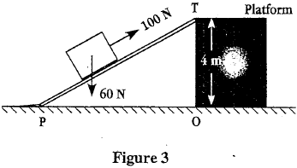
Calculate the length of the inclined plane if the work done in moving the load from point P to point T is 300J.
A. 25m B. 15m C. 5m D. 3m
10.What is the potential energy of the load at position T?
A. 6,000J B. 400J C. 60J D. 25J
11.Which of the following is a property of solid?
A. No fixed volume
B. Easy to compress
C. No defined shape
D. Difficult to compress
12. Figure 4 shows an electric circuit.
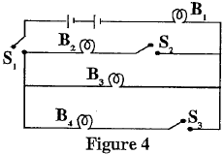
Which bulbs would give light if S₁ is closed while S₂ and S₃ are opened?
A. B₁ and B₂ B. B₂ and B₄
C. B₁ and B₃ D. B₃ and B₄
13. What would be the effect of adding another bulb in parallel?
- Total current would increase.
- Total current would decrease.
- Voltage would increase.
- Voltage would decrease.
14. Calculate the resistance of a wire if current flowing through it is 3A and the voltage across its ends is 12V.
A. 36 B. 15 C. 4 D. 0.25
15. Figure 4 is a circuit diagram showing how a substance is coated with copper. Use it to answer Question 15 .
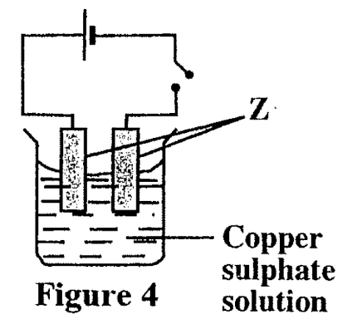
What name is given to the parts labelled Z?
A. electrodes B. cathodes
C. anodes D. nails
16. What effect of current is demonstrated in Figure 4?
- Heat effect C Magnetic effect
- chemical effect D. lighting effect
17. What is the similarity between “magnetic force” and “gravitational force”?
- The strengths depend on distance.
- Their attractions depend on the type of material.
- They both attract any material.
- They both attract metals only.
18. Which of the following correctly represents lines of magnetic force between two poles of magnets?
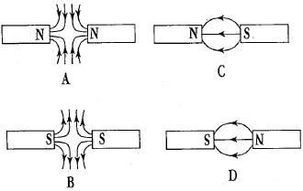

19. What is the density of a 40 g cube with each side 2 cm long.
A .5 g/cm³ B. 10 g/cm³
C. 20 g/cm³ D. 80 g/cm³
20. Which of the following substances would float in a liquid of density 0.78 g/cm³?
- wood of density 0.75 g/cm³
- petrol of density 0.8g/cm³
- water of density 0.90g/cm³
- glass of density 2.6g/cm³

SECTION B (50 MARKS)
21.a. Define scientific investigation.
_____________________________________________________________________________________________________________________________________________________(1 mark)
b. Table 41shows data collected by a student in an investigation.
Table 1
Age of Child (months) | Mass of Child (kg)
1 | 6
2 | 8
3 | 11
4 | 12
- What was the aim of the investigation?
__________________________________________________________________________________________________________________________________ (1 mark)
- What conclusion can be drawn from the investigation?
_____________________________________________________________________________________________________________________________________________(1 mark)
22a. Mention any two reason why should one follow safety rules when working in the laboratory
_________________________________________________________________________________________________________________________________________________2 marks)
b. Below is a diagram of a laboratory hazard symbol

i, Name the hazard symbol above
_____________________________________________________________(1 marks)
ii. describe two precaution measures when handling the equipment labelled the symbol above
__________________________________________________________________________________________________________________________________________________ (2 marks)
23. a. Figure 8 is a graph of electrical resistance against length of a nichrome wire.
i. Calculate the slope of the graph.

(3marks)
ii. What is the relationship between electrical resistance and length of the wire?
____________________________________________________________________________________________________________________________________________________(1 mark)

e. Convert 2km into cm

(3amrks)
24. a. Define expert opinion.
____________________________________________________________________________________________________________________________________________________(1 marks)
b. Mention any three roles of expert opinion in studying physics.
_________________________________________________________________________________________________________________________________________________________________________________________________________________________________ (3 marks)
25. Figure 6 shows a setup of an investigation.
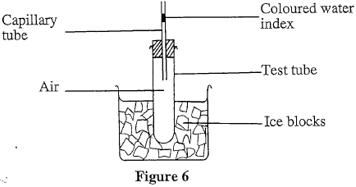
- What was the aim of the investigation?
______________________________________________________________________________________________________________________________________________(1 marks)
- What would happen to the water index after some time?
_______________________________________________________________________________________________________________________________________________(1 mark)
- Give the reason for your answer in 23 b above
_____________________________________________________________________________________________________________________________________________________________________________________________________________(2 marks)
26a.Define average density
. ____________________________________________________________________(1 mark)
b. Give any two effects of anomalous expansion of water
_______________________________________________________________________________________________________________________________________________________________________________________________________________________________(2 marks)
27. a. State the law conservation of energy
_____________________________________________________________________________________________________________________________________________________(1 mark)
b. Figure 8 is a diagram showing a pendulum. If the bob is pulled to point A and released, it swings between point A and C through the rest position, B.
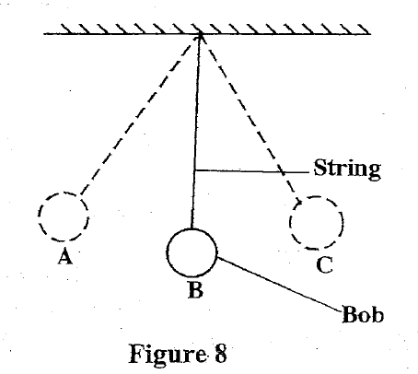
(i)What form of energy will be maximum at point B?____________________________(1 mark)
(ii)Give a reason for the answer in 25.b.(i).
____________________________________________________________________ (1 mark)
(iii)What energy changes take place as the bob moves from point A to C?
____________________________________________________________________________________________________________________________________________________(2 marks)
(iv)State the energy changes that take place at a hydroelectric power station.
______________________________________________________________________________________________________________________________________________(3marks)
28. a. Table 1 shows the readings of electric current in bulbs A, B and C and the voltage readings across the bulbs in a circuit.

Bulb | Current (A) | Voltage (V)
A | 0.3 | 1
B | 0.1 | 2
C | 0.2 | 2

a. Which bulbs are connected in parallel? ____________________________________(2 marks)
b. Give a reason for the answer to 32.a.
____________________________________________________________________________________________________________________________________________________(1 mark)
- Draw a circuit diagram which shows how the bulbs A, B and C are connected.

(3 marks)
29. a. State the law of magnets
__________________________________________________________________________________________________________________________________________________(1marks)
b. Describe you can identify the poles of a bar magnet.
____________________________________________________________________________________________________________________________________________________________________________________________________________________________________________________________________________________________________________________________________________________________________________________________(4marks)
30. Table 2 shows current passing through a bulb and voltage across it.
Using a scale of 2 cm to represent 2 volts on the vertical axis and 2 cm to represent 0.2 amperes on the horizontal axis, plot a graph of voltage against current.
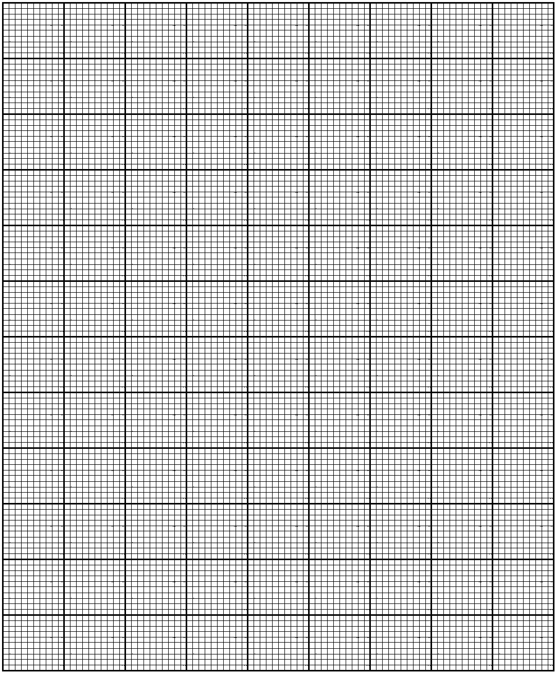 (5 marks)

SECTION C (30MARKS)
31. With the aid of a well labelled diagram, describe an experiment to show that cooking oil expand more than equal volume of water, for the same rise in temperature.

________________________________________________________________________________________________________________________________________________________________________________________________________________________________________________________________________________________________________________________________________________________________________________________________________________________________________________________________________________________________________________________________________________________________________________________________________________________________________( 7marks)
b. Explain why density of substance increases as temperature decreases.
________________________________________________________________________________________________________________________________________________________________________________________________________________________________________________________________________________________________________________(3 marks)
32. Describe any two applications of thermal expansion of solids
__________________________________________________________________________________________________________________________________________________________________________________________________________________________________________________________________________________________________________________________________________________________________________________________________________________________________________________________________________________________________________________________________________________________(4 marks)
b. Describe an experiment that can be done to determine the density of a regular metal block.
______________________________________________________________________________________________________________________________________________________________________________________________________________________________________________________________________________________________________________________________________________________________________________________________________________________________________________________________________________________________________________________________________________________________________________________________________________________________________________________________________________________________________________________(6 marks)
33. With the aid of a well labelled diagram, describe an experiment to show that electric current has a heating effects.

___________________________________________________________________________________________________________________________________________________________________________________________________________________________________________________________________________________________________________________________________________________________________________________________________________________________________________________________________________________________________________________________________________________________________________________________________________________________________________________________________________________________________________________________________________________________________________________________________(10marks)
END OF QUESTION PAPER

